Book your blood test (phlebotomy) appointment online
If your UCLH doctor or GP referred you for a blood test, you can now book your phlebotomy slot (blood draw appointment) online.
The new system helps to keep patients safer through social distancing by reducing the number of patients in any one location at a specific time. At the moment, you can only book your appointment up to seven days in advance.
How to book your phlebotomy appointment
- Scan the QR code below with the camera on your phone/tablet.
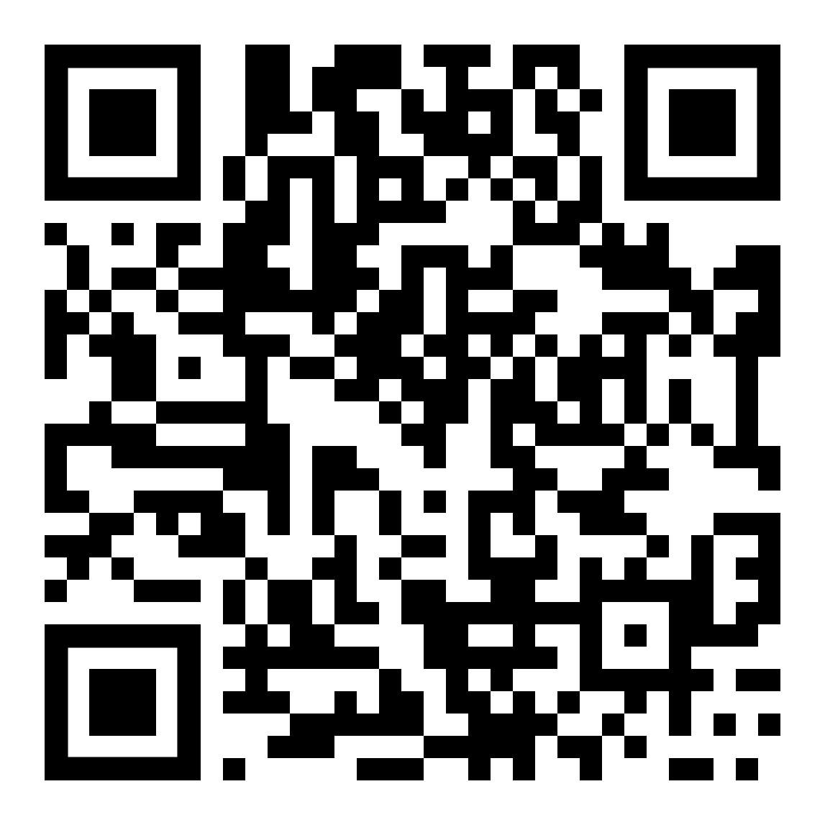
Alternatively, you can just type https://mycare.uclh.nhs.uk/mycare/openscheduling into the web browser on your device or computer

- Select your appointment slot and confirm your patient details:

- Choose a Specialty: Phlebotomy will be selected for you (do nothing)
- Choose a Type of Appointment: UCLH (at one of our UCLH sites) or GP (at a GP community site)
- Choose a Time: Click on the All buttons to select or deselect available locations and days
- Confirm and Schedule: Check appointment details and click on BOOK IT!
- You’re Almost Done:
  - Schedule as a Guest (add your patient information and confirm your details if you are not a MyCare UCLH patient portal user)
or you can
  - Log in and schedule it! (use this option if you are a registered MyCare UCLH patient portal user).
If you are unable to book online or have issues with your booking, please contact the UCLH Pathology team.
Tel: 020 3447 9051 (between 09:00 and 17:00 weekdays)
Email: uclh.patientbloodtestrequest@nhs.net

