Museum Practice Action Plan in response to COVID-19 Outbreak

Information for patients (updated 23.3.20)

Dear Patients

Thank you for your understanding at this challenging time. Our team has been working hard behind the scenes to aim to provide you the best possible care.

We plan to keep you and the practice population updated, continuing to offer continuity of care and support while modifying the consultation system to ensure safety for both patients and staff alike. We continue to review the latest guidance from NHS England and Camden CCG Medical Directors regarding the Coronavirus outbreak, keeping up to date with advice.

Some of the measures we have taken are as follows:
1. Patients understand they should not come to the surgery if they suspect COVID-19 or cough, fever & cold symptoms.
Patients have been asked to follow the NHS 111 online advice https://111.nhs.uk/covid-19 if you are worried.

ONLY call 111 if you have SEVERE symptoms like shortness of breath and cannot manage home.

Most cases will settle on their own with no medical help needed within 7 -8 days.
It is important to take paracetamol only for fever or pain, drink plenty of fluids & eat well. Please avoid ibuprofen, naproxen anti-inflammatories.

2. COVID-19 Definition:

The definition for COVID-19:

⁃ Anyone with a continuous cough OR fever (>37.8) must self-isolate for 7 days if you live ALONE or for 14 days for the ENTIRE HOUSEHOLD if one person is unwell (this includes children)

⁃ Travel history is now irrelevant

⁃ Anyone with these symptoms who is WELL can just stay at home and does not need to ring 111 and will NOT be tested

⁃ Anyone with these symptoms who is UNWELL should call 111 for advice if cannot cope or severely unwell. They must NOT come to the surgery.

111 will assess and advise you accordingly.

Most cases will settle on their own with no medical help needed within 7 -8 days.

There may be long waits for 111 so please use the service for urgent queries or severe symptoms.

https://www.gov.uk/government/publications/covid-19-stay-at-home-guidance/stay-at-home-guidance-for-households-with-possible-coronavirus-covid-19-infection

To prevent the spread of the virus please social distance.

How to Social distance

Or follow this link:
https://www.gov.uk/government/publications/covid-19-guidance-on-social-distancing-and-for-vulnerable-people/guidance-on-social-distancing-for-everyone-in-the-uk-and-protecting-older-people-and-vulnerable-adults

3. Telephone Lines:
We realise the phones will be busier than usual. We are using our personal mobiles to reduce traffic on the surgery lines.

You may receive calls where the number turns up as ‘Blocked’ due to a privacy setting.

If you do request a Telephone Consultation / call back from us, please ensure that we have your correct contact details, your mobile phone is switched on and that it is at hand.

4. Consultations:

Telephone consultations
All online-bookable face to face appointments have now been disabled and converted to telephone appointments which are bookable online.

These are clearly marked “TELEPHONE APPOINTMENTS ONLY – DO NOT ATTEND” – if someone attends without being triaged first they will be sent home and then called.

‘Patient Partner’, the phone system to book appointments has also been disabled so that we can carefully manage risk.

We have a TOTAL triage system such that all appointments are assessed via telephone first.

Video consultations
In some cases, these will be utilised by clinicians. You may wish to review this link on what to expect for a Video consultation:
https://www.youtube.com/watch?v=xxW4ssN3y90

Face-to-face consultations
These are being booked by clinicians only if this is clinically necessary and in a safe controlled environment.

Some of our doctors will be working remotely, away from the surgery if they need to stay at home either if they are self-isolating or have a medical condition that stops them working on site.

4. Repeat prescriptions:
We will review patients over the phone or video. Prescriptions will be sent directly to the chemist (via the Electronic prescribing service – EPS). If you haven’t nominated a chemist please let our receptionist know.

Please do not over order or stock pile as this will have an impact on other patients. We have been advised to issuing 28 days supply of medicines at a time to ensure everybody has what they need.

We can arrange repeat dispensing for regular medications. The repeat dispensing service enables the pharmacy to issue regular medicines to suitable patients who have been issued batch prescriptions without the need to request it from the GP surgery.

For more information visit:
https://www.nhs.uk/using-the-nhs/nhs-services/pharmacies/electronic-prescription-service/

5. Nurse appointments:
These will be triaged to ensure patients are not symptomatic or unwell (viral illness / symptomatic for coronavirus).

Sandra will do routine reviews over the phone e.g. for asthma, COPD & diabetes. She will continue to give childhood immunisations and important immunisations for adults. Routine smears can be deferred. Urgent smears tests will continue.

During this emergency period, we will not be giving travel advice or immunisations.

7. Hospital & Other Services

There are likely to be significant changes over this period and you may experience delays or suspension or routine in outpatient appointments and appointments for investigations.
Services are being reduced to concentrate on emergencies.

Please bear with the NHS over this period and look out for updates.
If your concerns are more of an urgent nature, do contact our surgery
Where possible, other services within the NHS will also be using phone or video technology to reduce risk of infection.

8. Routine GP services or private medical work

We have stopped all non-urgent work as per national guidance.

This includes:
- Travel advice and travel vaccinations
- New patient reviews - we will conduct this over the phone
- Blood tests - All non-essential tests to be suspended
- Non-essential referral
- Non-essential investigations
- All ‘non-essential’ paper work e.g. housing letters, insurance forms, letter for mitigating circumstances for universities or schoo, taxi medicals, ….etc

We will continue to give childhood immunisations as this very important at this time.

9. Sick Notes

For the first seven days off work, employees can self-certify so they don’t need any evidence for their employer.

For isolation notes:
https://111.nhs.uk/isolation-note/

This applies if you have been told to stay at home because of coronavirus and you need a note for your employer.
This service is only for people who:
- have symptoms of coronavirus and have used the 111 online coronavirus service
- have been told by a healthcare professional they have symptoms of coronavirus
- live with someone who has symptoms of coronavirus

We will continue to update you on any new developments.
You will have heard this elsewhere too but do remember to wash your hands, regularly and thoroughly.
We know that we are all having to make changes to the ways we live and work, but if we ALL play a part in being sensible and careful, isolating ourselves, keeping our distances, ensuring that our loved ones and friends are doing so too, we will have a better chance of overcoming the current challenges.
At the bottom of this page, you will find a list of potentially useful links.
Finally, some sensible thoughts on how to keep well by Henrietta Fore, Executive Director of UNICEF
https://www.youtube.com/watch?v=bb0uoJHNcNY

Wishing you our very best,
The Museum Practice Team

Useful Links:

- For Parents & children

Child Friendly Explanation of Coronavirus.pdf

When should I worry-Booklet; Guidance for Parents

- Self Isolation

https://www.nhs.uk/conditions/coronavirus-covid-19/self-isolation-advice/

Isolation notes https://111.nhs.uk/isolation-note/

- How to Social distance

https://www.gov.uk/government/publications/covid-19-guidance-on-social-distancing-and-for-vulnerable-people/guidance-on-social-distancing-for-everyone-in-the-uk-and-protecting-older-people-and-vulnerable-adults

- Data protection & information sharing

https://ico.org.uk/about-the-ico/news-and-events/news-and-blogs/2020/03/data-protection-and-coronavirus/

- Insomnia
An online sleep-improvement programme based on CBT (Cgnitive Behavioural therapy)
https://www.sleepio.com/work/nhs/

- Mental health

https://www.mentalhealth.org.uk/publications/looking-after-your-mental-health-during-coronavirus-outbreak

https://www.mind.org.uk/information-support/coronavirus-and-your-wellbeing/#collapsebdc84

https://www.samh.org.uk/about-mental-health/self-help-and-wellbeing/coronavirus-and-your-mental-wellbeing

https://www.good-thinking.uk/

- Self-isolation help:

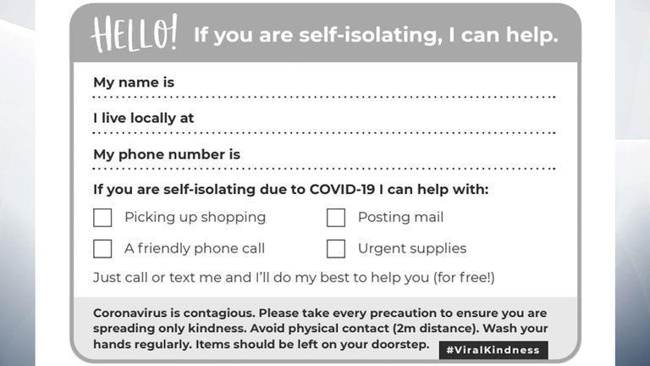

- Self- Care Advice

https://www.uclh.nhs.uk/MSK/Pages/CamdenMSK.aspx

This list is not exhaustive but hopefully a small help to navigate the complex situation we face ourselves in.

